BEE Project Proposal

Microphone Circuit

**5/2/2012**

**Course:-** BESE – 16A

**Submitted by:-**

1. NC – Saad Masood
2. NC – Aneeq Ashraf
3. NC – Hanzla Mateen
4. PC – Humza Aamir

**Submitted to:-** Lab Engr. Abdul Basit

Table of Contents

**Project Title3**

**Goal3**

**Components Used3**

**Estimated Cost3**

**Circuit Diagram4**

**Background information5**

**Some comments on our choice of ICs6**

**Simple Intercom System7**

**Possible Improvements/ Practical Application7,8**

**Project Title:-** Microphone Circuit

**Goal:-** Is to build microphone circuit.

**Components used:-**

|  |  |  |  |  |
| --- | --- | --- | --- | --- |
|  | **Qty** | **Name** | **Short name** |  |
|  | 1 | Electric Condenser Microphone Cartridge | MIC |  |
|  | 1 | LF353N Dual Wide-band JFET Op-amp | U1 |  |
|  | 2 | 2.2kOhm 1/4W | R3,R5 |  |
|  | 2 | 10kOhm 1/4W | R1,R2 |  |
|  | 1 | 33kOhm 1/4W | R4 |  |
|  |  |
|  | 1 | 10k trimpot | R6 |  |
|  | 1 | 1uF 25V electrolytic (PC lead) | C1 |  |
|  | 1 | 10uF 25V electrolytic (PC lead) | C3 |  |
|  | 2 | 100uF 25V electrolytic (PC lead) | C6,C7 |  |
|  | 1 | 0.001uF capacitor (CKO5 low-volt. Ceramic) | C2 |  |
|  |  |
|  | 2 | 0.1uF capacitor (CKO5 low-volt. Ceramic) | C4,C5 |  |

**Estimated Cast:-** 500 rupees.

**Circuit Diagram:-**

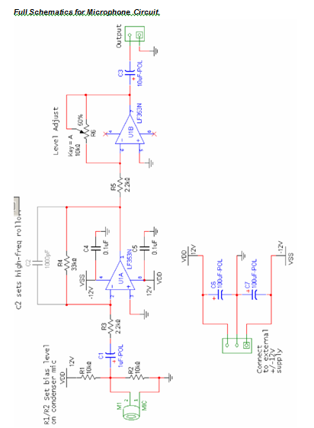

**Background information**

***Microphones***

A speaker can be used in reverse to create a microphone. In the case the incoming sound wave leads to a mechanical deflection of the cone and voice-coil. According to Faraday’s law, a time-varying current will be induced because the coil is moving in through a magnetic field (produced by the permanent magnet). Although any speaker could be used for a microphone, most speakers are unnecessarily large for this purpose, except in simple intercom applications where it is common to use the same component to perform both the speaker and microphone functions.

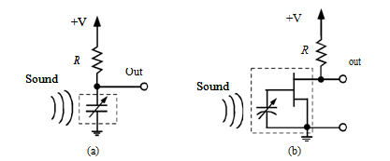

Figure 1-2 – Two types of condenser (capacitance) microphones. (a) standard condenser mic.

(b) electret condenser mic. The electret uses a special capacitance with a fixed charge (an electret) integrated with a FET buffer. The dashed line indicates the internal detail of the microphone cartridge; the resistor is supplied externally by the designer.

[http://en.wikipedia.org/wiki/Microphon](http://en.wikipedia.org/wiki/Microphone)e  [http://www.acoustics.salford.ac.uk/acoustics_world/id/Microphones/Microphones.ht](http://www.acoustics.salford.ac.uk/acoustics_world/id/Microphones/Microphones.htm)m

**Some comments on our choice of ICs**

***Why the LM353?***

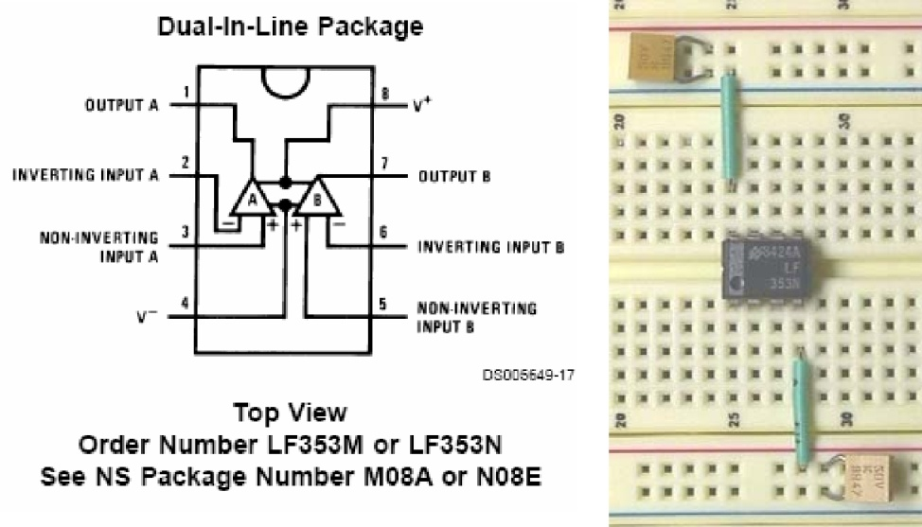Almost any generic op-amp can be used for a microphone pre-amplifier. The signal levels are very low, and all we need is a simple gain stage with high input impedance. If we were to operate the microphone circuit from a battery, the LM358 would be fine.

Figure 1-4 – LF353 pinout, and example power connections and bias decoupling capacitors.

This is a good place to offer a tip about using op-amps in analog or mixed- signal circuits: it is considered good practice to always include bias-decoupling capacitors for each IC in the circuit.  Figure 1-4 shows the pinout and bias arrangement for the LF353 on a breadboard. To understand why the capacitors are useful, consider the fact that most circuits are processing time-varying or rapidly switching signals, and thus the DC current draw from the power-supply rails is not a constant. Instantaneous current surges in one part of the circuit can cause the supply voltage or current to vary in other parts of the circuit. Thus the bias-decoupling capacitors at each IC serve as a local charge reservoir to help maintain a steady supply current during operation. Obviously the bigger the capacitance the better, but 0.1µF is a very common choice. Unless your design is tightly constrained in terms of cost and parts count, it is advisable to add these decoupling capacitors in all your op-amp circuits.

**Simple Intercom System**

The last step is to hook up both circuit modules (microphone and audio amplifier/speaker) to make a complete audio system that detects/receives an acoustic signal, electronically amplifies it and transmits it over a cable, and converts it back to an acoustic signal. This is obviously the basis of most telephone, intercom, and public address systems.

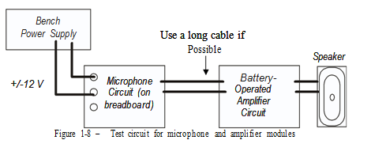

**Possible Improvements/ Practical Application**

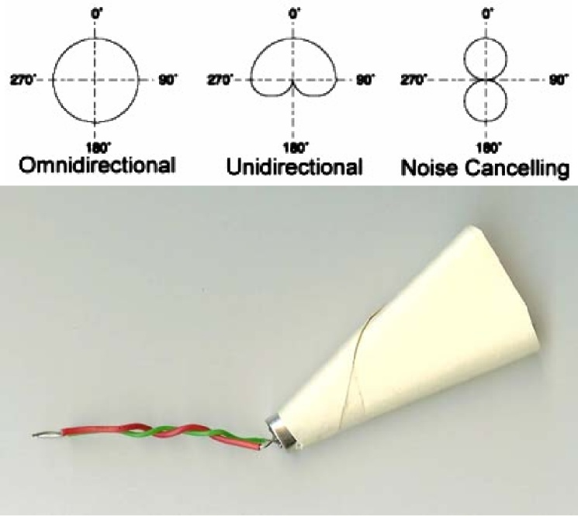In contrast to the audio amplifier, potential improvements to the microphone circuit are more subtle, and largely involve the microphone itself, not the electrical circuit. The little omnidirectional electret component that we choose is very convenient because it is small, and cheap, but do we really want an omni-directional mic in our system? Probably not, since people are usually speaking directly into the mic, hence the omni-directionality just creates problems by picking up unwanted noise from the surroundings, or undesired feedback from

the distant speaker. There are some electrets on the market that have a more unidirectional “cardoid” reception pattern, but these are quite expensive. One fairly simple way to make our mic directional is to put a little cone around it, which can be fashioned out of some heavy paper as shown in  Figure 1-10.

* Condenser microphones are very sensitive devices, and will generate a signal in response to any nearby air movement. In a “windy” environment, such signals can easily swamp out the desired audio signal. So another useful improvement is to put some kind of a “windscreen” in front of the microphone. The windscreen is, in effect, a

Mechanical high-pass filter, and helps improve

Figure 1-10 – Common microphone directional receiving patterns. The photo shows a simple method to improve the directionality of the microphone

the dynamic range of the microphone. Even

with the windscreen, microphones can still be

sensitive to bursts of air associated with the

actual voice signal, such as “p” sounds. These

effects can be reduced with a so-called “pop-filter”, which is a large windscreen some distance away from the microphone. You will often see such things on microphones used in professional recording studios, as in  Figure 1-11.

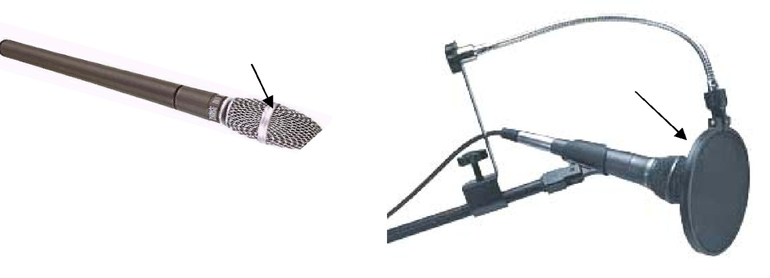

Another potential improvement to minimize noise pickup is to use a balanced amplifier configuration instead of the single-ended system we used. One example is described in <http://www.eclectic-web.co.uk/index.php?jump=mike/electret_a.htm> .

A typical vocal signal is comprised mostly of frequencies in the 300-3000 Hz range. Therefore, any frequencies outside of this range are unnecessary in our system and hence represent unwanted noise. Thus one improvement might be to include a bandpass “speech filter” in the system to pass only frequencies in the vocal range. One possible 2nd-order active bandpass speech filter schematic is shown in  Figure 1 -12, comprised of cascaded low-pass and high-pass filters. This is not the only way to make a bandpass filter, but it is an easy one to understand. We will use similar filters in the design of the AM receiver in a later lab

